Pre-requisite - Core Java or Typescript

Stage 1 - Web automation (Playwright) and API automation (Playwright & Rest assured) & Mobile Web UI automation (Playwright)
Stage 2 - Hybrid Framework (TestNG, Page Object Model, Data Driven Framework, Keyword Driven Framework)
Stage 3 - BDD Framework
Stage 4 - CI (git & Jenkins)

Session - 9:30 to 1:30 PM IST
Break - 11:15 to 11:30 AM IST

Assessment -
- Pre-test MCQ
- Mid-test MCQ
- Post-test MCQ & Caption project

Git Links:
Java Playwright - https://github.com/balaji-githubstore/java-playwright-kpmg-jan-2026.git
Typescript playwright - https://github.com/balaji-githubstore/typescript-playwright-kpmg-jan-2026.git
Hybrid Framework - https://gitshub.com/balaji-githubstore/java-hybrid-framework-playwright-kpmg-jan-2026.git
BDD Framework - https://github.com/balaji-githubstore/java-bdd-framework-playwright-kpmg-jan-2026.git
API Automation - https://github.com/balaji-githubstore/java-api-restassured-kpmg-jan-2026.git

Core java
- Architecture
Source code (.java) → Bytecode (.class) → O/P

Playwright Using Java
- Installation
  - JDK 17 or above
    - JRE
  - Eclipse
- UpperCamelCase → MyFirstProject
lowerCamelCase → myFirstProject
- Eclipse structure
Workspace
Project - UpperCamelCase
Package - lowercase (com.companyname.purpose)
Class - UpperCamelCase
Methods and variables - lowerCamelCase

- Maven - Build management tool ava+selenium webdriver lib) → driver → Browser

- Architecture of a playwright (websocket)
Source code (Java+Playwright lib) ←→ nodejs server ←> Browser
  - Pom.xml - Project Object Model
    - Helps to configure the jars (libraries) required for the project. It will also take care of any dependent libraries
    - Control the project using the command line using goals
    - Easily migrate the project because of its lightweight nature

- Create a Maven project using Eclipse (Maven - Build management tool )
  - Add groupid
  - Add artifact id
- Set up the playwright libraries
  - https://mvnrepository.com/artifact/com.microsoft.playwright/playwright

- Architecture of Selenium WebDriver (stateless - rest api http)
Source code (J

- Assume we do page.click() (playwright → sends json message over websocket)
- Nodejs. Driver : interprets and send native commands to browser
- Browser responds → message sent back over the same socket

- Launch the browser
  - Playwright instance
  - Browser
  - Context
  - Page
- Click, type, select
- Inspect the element → tagname, attribute, text or not
- Auto wait concepts in Playwright
  - https://playwright.dev/java/docs/actionability
- nth method - locator - index start at 0
page.locator("xpath=//input[@id='sex']").nth(2).click();
    - Value
    - Index
  - Without the select tag
    - Using click()
- Multiple tabs/windows
- Frame - html embedded into another html
  - Even though the locator is correct, we get no locator found error.
  - Check for tagname - frame or iframe
  - Get into the frame
    - Using xpath
    - Using name or url or url contains
- Dropdown
  - With the select tag
    - Label
- To inspect → f12 or ctrl+shift+c
- Alert
  - Javascript alert (auto-handled in Playwright)

- Upload (anyone options)
  - Traditional setFiles using locator method
    - Check for //input[@type='file']
  - waitforFileChooser()
  - onfilehooser()
- Download
- Shadow root
  - We can automate using css selector
- Dynamic table

—------------------------------------------------------------------------

Git – Git is a free and open source distributed version control system.

Architecture

Project (in local machine) → local repository (in local machine) → remote repository (GitHub, Bitbucket, GitLab)

Git concepts:
modified -> staged → commit

To update the project to remote repo
- git init → create local repo
- git add . → stage all the files
- git commit -m “first commit” → update the local repo

- git remote add origin1 https://github.com/balaji-githubstore/java-playwright-kpmg-jan-2026.git → register the remote url using name origin
- git push -u origin1 master → update the remote repo from the local repo
Assume - we are adding new test case.
- Clone the repository
- Create your branch (copy from master)
- Work on your branch
- Push your branch
- Create PR in github to merge your branch to origin/master (remote)

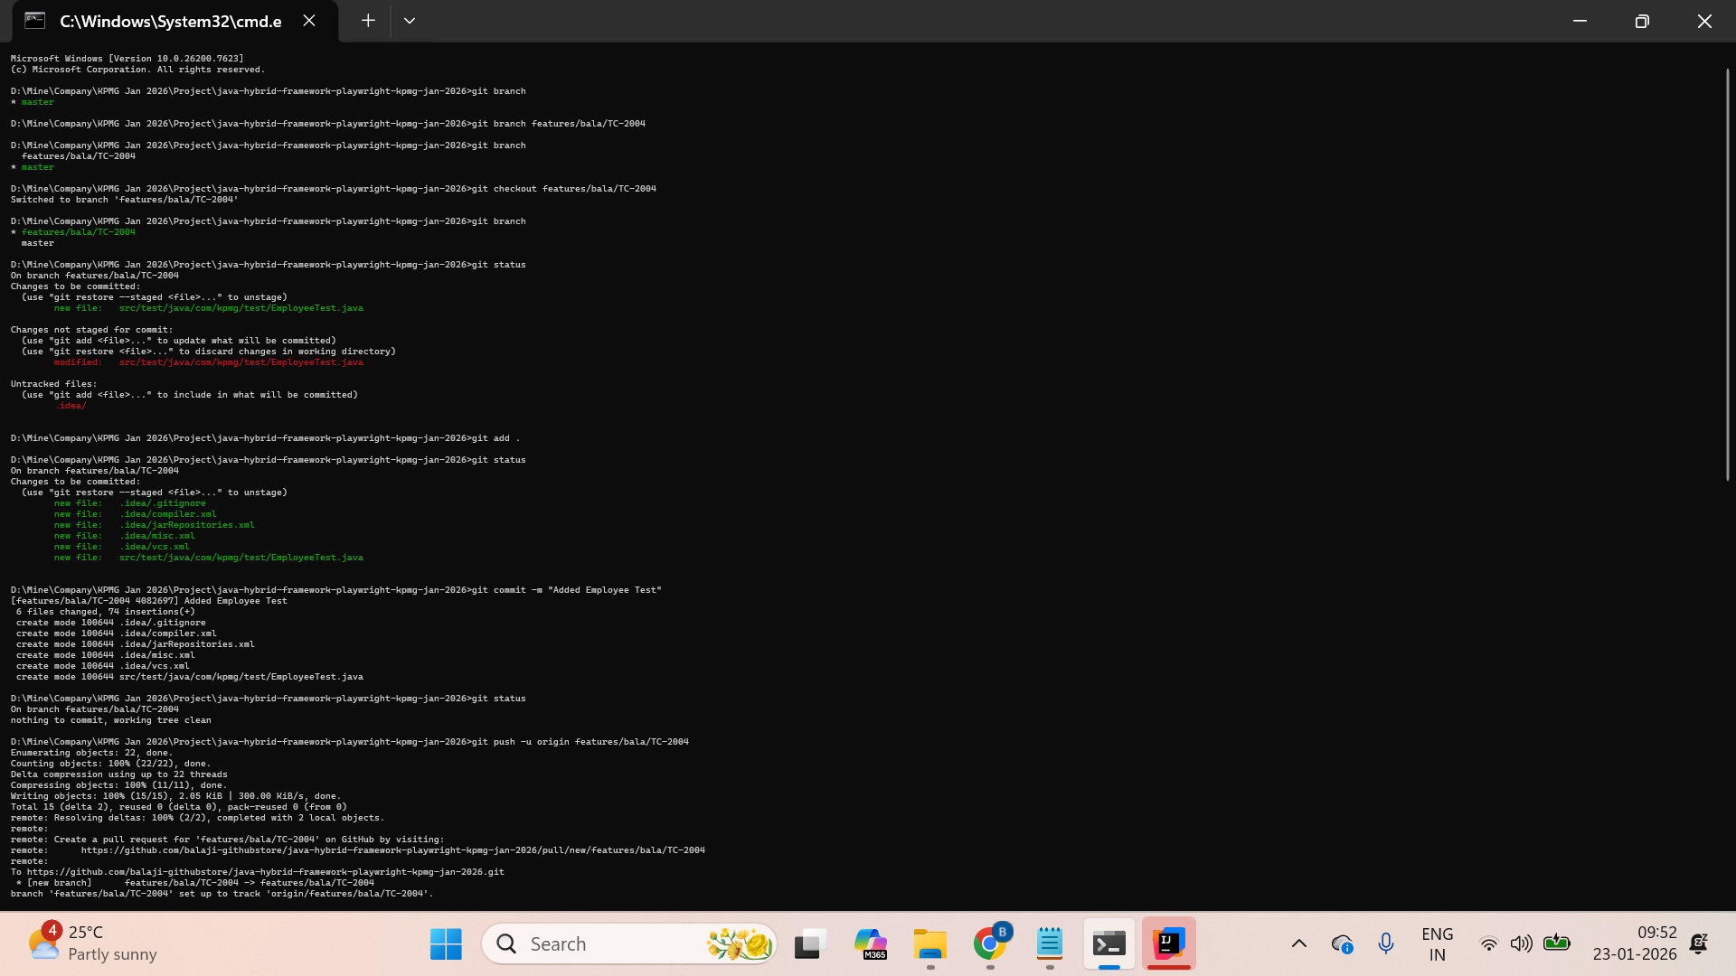

—-----------------------------------------------------------------------------------

Hybrid Framework
- Unit Test Framework - TestNG or Junit
- Data Driven Framework - Separating the test method and test data in different files. (excel, json, properties)
- Page Object Model - For effectively handling the web pages and web elements

Keyword Driven Framework - For managing the playwright keywords.

Package
com.kpmg.test → Test classes and Test methods
com.kpmg.base → Browser and report configurations
com.kpmg.utilities → Classes with reusable code for working with Excel, JSON, and properties.
com.kpmg.pages → Page classes and Page methods

Eclipse setup plugin (only once for Eclipse) → Install TestNG for Eclipse
Eclipse setup plugin (only once for Eclipse) → Install cucumber for Eclipse

Steps to create a framework
- Create maven project
  - Add groupid
  - Add artifcat id
- Add dependencies
  - Testng - https://mvnrepository.com/artifact/org.testng/testng/7.11.0
  - Playwright - https://mvnrepository.com/artifact/com.microsoft.playwright/playwright/1.57.0
- Create test package, class, and test method (@Test)
- Every @Test should have at least one assertion. Assertion decides whether the @Test passes or fails.
- @Test runs on ASCII keycode order. To change it, we can use the priority attribute.
- Annotations
  - @BeforeMethod - runs before each @Test
  - @AfterMethod - runs after each @Test even @Test fails
- Configure the git for the framework
- TestNG auto-generated reports using Eclipse
  - Emailable report
  - Index.html - consolidated report

- @DataProvider - helps to run @Test with multiple sets of test data.
  - Create @Test with proper arguments/parameters
  - Create a method that returns a two-dimensional array, and also provide the @DataProvider annotation
  - Connect the @Test with @DataProvider
- Excel - Read
  - Poi - https://mvnrepository.com/artifact/org.apache.poi/poi
  - Poi-ooxml - https://mvnrepository.com/artifact/org.apache.poi/poi-ooxml/5.5.1

To read Excel
- Location - Read/Write
- Open
- Sheet
- Row
- Cell

XSSFWorkbook - .xlsx
HSSFWorkbook - .xls

- Connect Excel to @DataProvider
- Page Object Model - Design pattern
  - Reuse
  - Maintenance
  - Readability
To implement the page object model
- For each web page, we need to create a class - Page Class
- Operations handled through the methods - Page method
- Collecting the object repository (locators) for web UI elements at the class level or in different level.

- Testng xml - XML Suite file
  - Parameterization - supply data from xml
  - Parallel execution
    - <test>
    - <classes>
  - Group the test methods to run
  - Control the testng project using this xml/command line easily

- Added PlaywrightKeywords class and inherited it in the Page object class
- Maven - Command line option/ Understanding Goals
  - Set up mvn in the env path variable
    - Download maven binary zip
    - Extract and add bin folder to the environment path variable
    - Open new command prompt and check
      - mvn – version
  - Go to pom.xml folder inthe command line
    - clean, compile, test, package, install

—---------------------------------------------------------------------------------------------------

BDD Framework - Behaviour Driven Development

Actual BDD - Behaviour Driven Development - main focus is understanding the requirements
Modified BDD - ATDD - Acceptance Test Driven Development - main focus is on writing acceptance testing

To implement BDD concepts
- Java and JavaScript - Cucumber - https://cucumber.io/
- Python - behave
- C# - ReqNRoll

When to implement BDD?
Stage 1 - Everyone in the team is crystal clear with the product requirement/outcome.
Stage 2- Some of the team member knows about the product requirement/outcome.
Stage 3 - Only top-level management knows about the product requirement/outcome.
Stage 4 - Some other organization done it earlier, but new tothe current organization
Stage 5 - Need to do R&D.

Architecture of Cucumber

Feature (.feature) → Step definition (.java)

Eclipse setup plugin (only once for Eclipse) → Install TestNG for Eclipse
Eclipse setup plugin (only once for Eclipse) → Install Cucumber for Eclipse

Steps to create a BDD Framework
- Create maven project
  - Add groupid
  - Add artifact id
- Add dependencies
  - cucumber-java - https://mvnrepository.com/artifact/io.cucumber/cucumber-java/7.33.0
  - cucumber-testng - https://mvnrepository.com/artifact/io.cucumber/cucumber-testng/7.33.0
  - Playwright - https://mvnrepository.com/artifact/com.microsoft.playwright/playwright/1.57.0

- Create a feature file
  - Add feature header
  - Add feature description
    - Unformatter description
    - Formatted description
In order to [application goal]
As a [role]
I would like to [visible change expected]

- Add Scenario
  - Provide scenario title
  - Should contain at least one given, when, then
given [Prerequisite]
when [Actions/Operation]
then [Assertion]

- Create tesng runner file and configure the Cucumber option, and then trigger it using testng
  - Add the missing step definition
- Step parameterization
  - Helps to reuse the code
  - Helps to reduce duplicates in the step definition
- Scenario outline
  - One scenario - run with multiple set of testcases
  - Reduce duplicates in the feature file

- Background -
  - Use when you have repeated given for all scenarios in a single feature file; otherwise, ignore it.
  - It is part of the scenario in the current feature file.
- Datatable
  - How to create a scenario?
  - How to read a DataTable in a step definition?

- Scenario outline with a datatable
  - No need to change anything in automation

- Cucumber options
  - dryRun → to find the missing step definition.
  - Publish - to publish in public git (not recommended)
  - Plugin - to generate a report locally
  - Tags - and, or, not
    - and - scenario that contains both tags will be triggered
    - Or - a scenario that contains any one tag will be triggered
    - not - exclude that scenario, the remaining will run
- Hooks
  - @Before - runs before each scenario
  - @after - runs after each scenario even though scenario fails.

- Maven - Command line option/ Understanding Goals
  - Set up mvn in the env path variable
    - Download maven binary zip
    - Extract and add bin folder to the environment path variable
    - Open new command prompt and check
      - mvn – version
  - Go to pom.xml folder inthe command line
    - clean, compile, test, package, install

Important Concepts - to improve reusability, readability, and maintenance
- Step parameterization - code reuse
- Scenario outline - one scenario - multiple sets of test cases
- Background - repeated given
- Datatable - tabular to single-step definition

—-------------------------------------------------------------------------------------------------------------------
API Automation - RestAPI
- Rest API method
  - Get
    - Path parameter
    - Query parameter
  - Post
  - Put/Patch
  - Delete
- Collect —-> Baseurl + resource (based on the request)
- REST - GET, POST, PUT, DELETE
- Validations - Status Code, Response Time, Response Body
- Model Classes, Serialization, Deserialization
- OpenAPI Specification for schema validation
- Refer git repo - readme -https://github.com/balaji-githubstore/java-bdd-framework-playwright-kpmg-jan-2026.git
  - Demo1GetMethods.java
  - Demo2PostMethods.java
  - Demo3ChainMethods.java
  - Demo4ReadResponse.java
  - Demo5OpenAPIValidation.java
  - Demo6Git.java

API Automation - Using Playwright
- Refer - https://github.com/balaji-githubstore/java-playwright-kpmg-jan-2026.git

—--------------------------------------------
Gen AI For Automation
- Generative AI
  - Trained on a massive dataset and learn pattern from data. Generate best output based on the given input (prompt)
- LLM → Subset of gen AI
  - GPT
  - Claude
- LLM doesn’t predict like a human, next token - predicting based on a large dataset.
Input prompt → tokenization → next prompt → final response

- Copilot → AI-powered code assistant helps developers/automation to code fast, heal the errors, and develop complete function.
  - Ask
    - Won’t think too long. Works similar chatgpt
    - Use
      - Explain the code
      - Generate a function for randnumber()
      - Fix the error
      - Write sql query
  - Agent (Autonomous mode) - directly modify the files
    - Define role
    - Can edit/create a file (before adding it, it will ask for permission)
    - Run refactor
    - modify/create/delete
  - Plan - helps AI think before it acts.
    - Use when to update the complete project
    - Detailed plan → before applying it
    - Use it when multiple files need to be updated
    - You can manually update plan and then approve
- Playwright MCP - available only for Node.js - https://playwright.dev/docs/test-agents
  - Nodejs
  - VSCode,
    - Extension - vs copilot & chat, playwright for test
  - npx playwright init-agents --loop=vscode
  - Start the MCP server in VS code for playwright-test
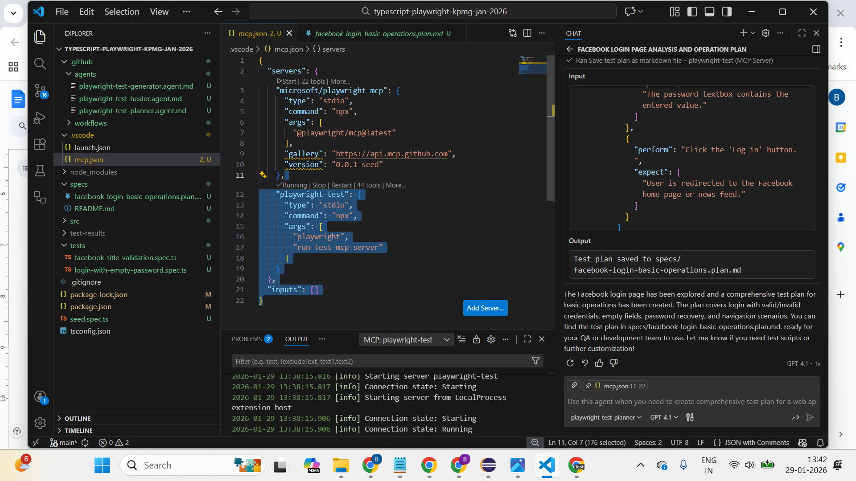

F. playwright-test-planner → plan test case for the application and store in .md file
G. Playwright-test-generator

Run the WAR file
The Jenkins Web application ARchive (WAR) file can be started from the command line like this:
- Download the latest Jenkins WAR file to an appropriate directory on your machine
- Open up a terminal/command prompt window to the download directory
- Run the command java -jar jenkins.war
- Browse to http://localhost:8080 and wait until the Unlock Jenkins page appears
- Continue on with the Post-installation setup wizard below
Jenkins
- Log in to Jenkins
- Configure Source Code Management
- Build triggers (POLL SCM)
- Build Steps

—--------------------------------------------------------------------------------------------

Typescript - Playwright
- Installation
  - Nodejs - https://nodejs.org/en/download
  - npm install -D typescript
  - npm install -D ts-node
  - npm init playwright@latest
    - Install the required option if it asks for any, and also verify playwright drivers are installed (installed from point c itself)
      - npx playwright install
- Typescript playwright - https://github.com/balaji-githubstore/typescript-playwright-kpmg-jan-2026.git

Please complete the pre-test → link available in chat window
- Register yourself for the test by providing your email ID.
- Sign in and go to the contest
- You can see the pre-test. Select and complete the test

IMPORTANT Assignment
Day 2
Task 1
1. Navigate onto https://www.medibuddy.in/
2. Close if any popup and Click on Login
3. Click on I have Corporate Account
4. Click on Learn More
5. Click on Skip
6. Click on Login using Username & Password
7. Enter username as john
8. Enter password as john123
9. Click on show password
10. Click log in
11. Get the error message shown and print it in the terminal

Task 2 (Important)
1. Navigate onto https://www.salesforce.com /in/form/signup/freetrial-sales/
2. Enter first name as “John”
3. Enter last name as “wick”
4. Enter work email as “john@gmail.com”
5. Select Job title as “IT Manager”
6. Select Employees as “101-500 employees”
7. Select country as “United Kingdom”
8. Do not fill the phone number
9. Click on check box
10. Click on start my free trial
11. Get the error message displayed “Enter a valid phone number”

—-------------------------------------------------------------------------------------------
Day 3
Task 1 (Important) - Multiple tabs Complete before Monday
1. Navigate onto https://www.online.citibank.co.in/
2. Close if any pop up comes
3. Click on My Account
4. Click on Banking with citi
5. In new tab
6. Enter userid as john123
7. Click on signup
8. Get the error displayed for the password

Task 2
- Navigate to https://secure1.inmotionhosting.com/index/login
- Click on visit our support center
- Click on “No Thanks” if any popup
- Search for “diskspace”
- Get the text “Search Results for: diskspace” and print it

Task 3 (Important) - Frame (may not work between 2 to 5 PM IST) - Complete before Monday

1. Navigate onto http://demo.openemr.io/b/openemr/
2. Update username as admin
3. Update password as pass
4. Select language as English (Indian)
5. Click on the login button
6. Click on Patient and Click New Search
7. Add the first name, last name
8. Update DOB as today's date (Use page.locator().fill(“hello”)
9. Update the gender
10. . Click on the create new patient button above the form
11. . Click on confirm create new patient button.
12. . Print the text from alert box (add ondialog handler to get the alert message)
13. . Handle alert (automatically handled by playwright)
14. Close the Happy Birthday popup
15. Get the added patient name and print in the console.

Day 4 (You can do it on Monday or Tuesday)

Task 1 (Important) - shadowroot element
1. Navigate onto https://www.royalcaribbean.com/account/signin
2. Click Create an account
4. First Name as Dennis
5. Last Name as Rich
6. Select Month as April
7. Day as 4
8. Year as 1990
9. Country as India
10. Any email address and password
11. Select as “What was your first car's make or model?”
12. Type answer
13. Accept the terms and condition
14. Click done

Task 2
- Navigate to https://datatables.net/extensions/select/examples/checkbox/checkbox.html
- Write logic to get and print all the names present on all the pages

—----------------------------------------------------------------------------------------------------------------------------

Optional Task (New to automation)
Task 1
1. Navigate onto https://nasscom.in/
2. Click on Login and then click on register
3. Enter First name as admin
4. Enter Last name as pass
5. Enter email address as admin@gmail.com
6. Enter company name as Google
7. Select IT Consulting from dropdown
8. No need to automate CAPTCHA
9. Click on Register

Task 2 - https://www.nasscom.in/nasscom-membership
- Fill the form except for the Revenue & Employee Details
- Click on calculate fee
- Get an alert text and print it

//input[@type='file' and @id='edit-field-additional-document-0-upload']

Reference -
- Lambda expression - https://www.geeksforgeeks.org/java/lambda-expressions-java-8/
- Consumer interface - https://www.geeksforgeeks.org/java/java-8-consumer-interface-in-java-with-examples/
- In java
  - If you need to reuse logic, then create methods
  - If you need to reuse methods/variable, try implementing inheritance.
- SOLID Principle -

Number of rows
//table[@id='example']/tbody/tr
Number of columns
//table[@id='example']/tbody/tr[1]/td

//table[@id='example']/tbody/tr[1]/td[2]

https://datatables.net/extensions/select/examples/checkbox/checkbox.html

—------------------------------------------------------------------

Class
Static variable
Non-static variable

Static method()
Non-static method()

constructor() → if you need any prerequisites for the object

this keyword
super keyword

—---------------------------------

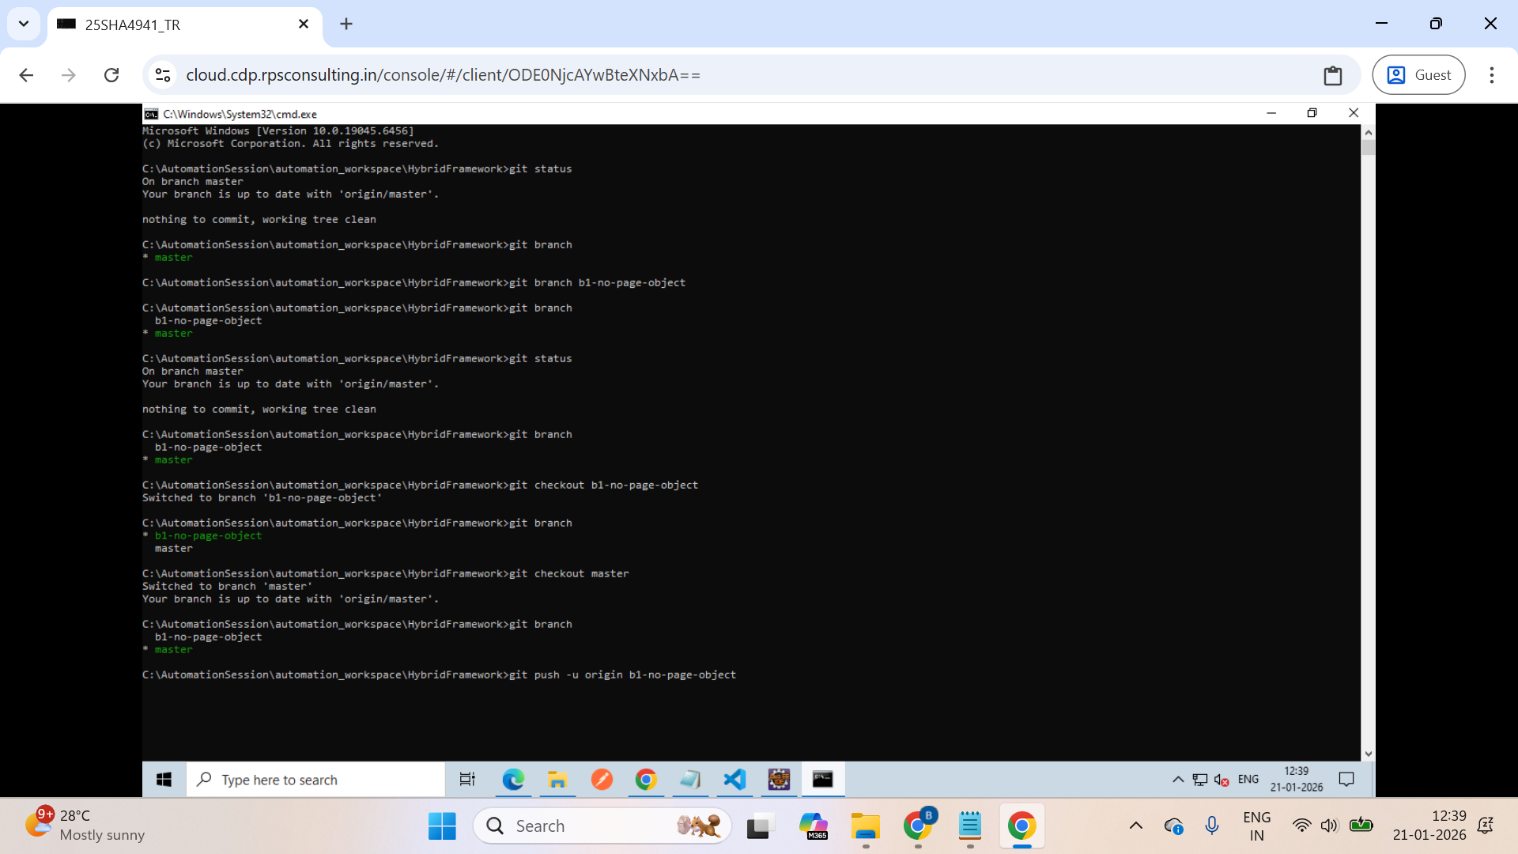

—-------------------------------

Framework
- Other utils like properties, JSON
- API automation - basic, jsonpath, jsonnode, advance pojo class for response, lombok, openAPIspec for schema validation
- Eclipse - lombok
- Playwright - api
- Extent Report and log4j → hybrid framework
- Understanding mvn goals → clean, compile, test, package → control the project in the command line using Maven. → clean, compile, test, package, install
- Mobile web ui simulation in playwright - https://github.com/microsoft/playwright/blob/main/packages/playwright-core/src/server/deviceDescriptorsSource.json

—---------------------

- YAML cheatsheet
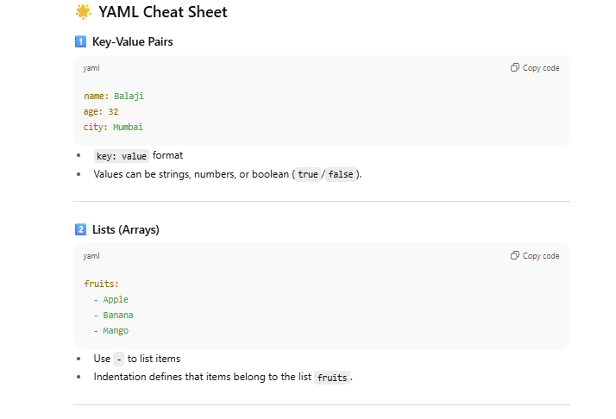
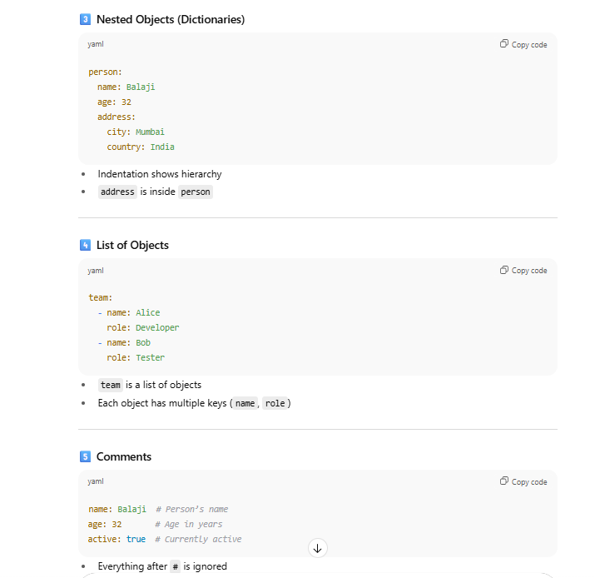
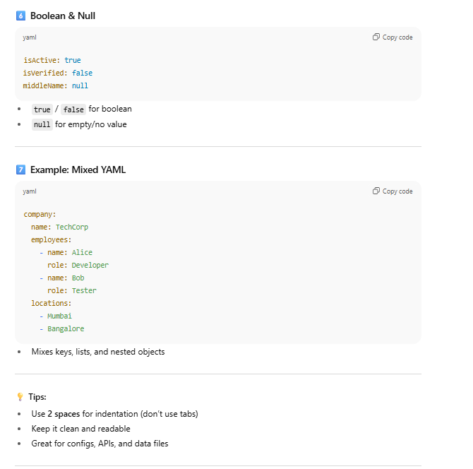

API Automation;
GitHub API for practice:
https://docs.github.com/en/rest/repos?apiVersion=2022-11-28

- List repositories for a user
- List repositories for the authenticated user
- Create a repository for the authenticated user
- Update a repository
- Delete a repository

